Student Information System
Sequence Diagrams Document

Version 1.0 | Based on ERD v1.0 | April 2025
12 Sequence Diagrams · All ERD Entities & Relationships Covered
Entities: UserAccount · Administrator · Student · Instructor ·
Course · Enrollment · Grade · CourseMaterial · Notification · Message

Introduction
This document contains 12 sequence diagrams derived directly from the ERD. Every entity and relationship in the ERD is exercised by at least one diagram. Each diagram shows the exact database table names, column names (with FK designations), and SQL-style operations that correspond to the ERD attributes.

ERD Entities covered: UserAccount, Administrator, Student, Instructor, Course, Enrollment, Grade, CourseMaterial, Notification, Message.
ERD Relationships covered: HasRole, RegistersIn, Includes, Receives, Triggers, Teaches, Has, Sends.

Naming convention: SC-## (Sequence) maps 1-to-1 with UC-## (Use Case) and AC-## (Activity Diagram).

SC-01 — User Login & Role-Based Redirect

Use Case: UC-16 (Authenticate / SSO Login)

Covers credential verification against the UserAccount table (Username, PasswordHash, Role), role resolution via the HasRole relationship to retrieve the correct role-specific profile (AdminID / StudentID / InstructorID), session token creation, and redirect to the appropriate dashboard. The ALT fragment handles invalid credentials.

ERD Entities & Attributes referenced:
• UserAccount: UserID, Username, Email, PasswordHash, Role
• HasRole relationship resolves to: Administrator (AdminID), Student (StudentID), Instructor (InstructorID)
• Session token scoped to UserID + Role
Actors: Student, Instructor, Administrator (any role)

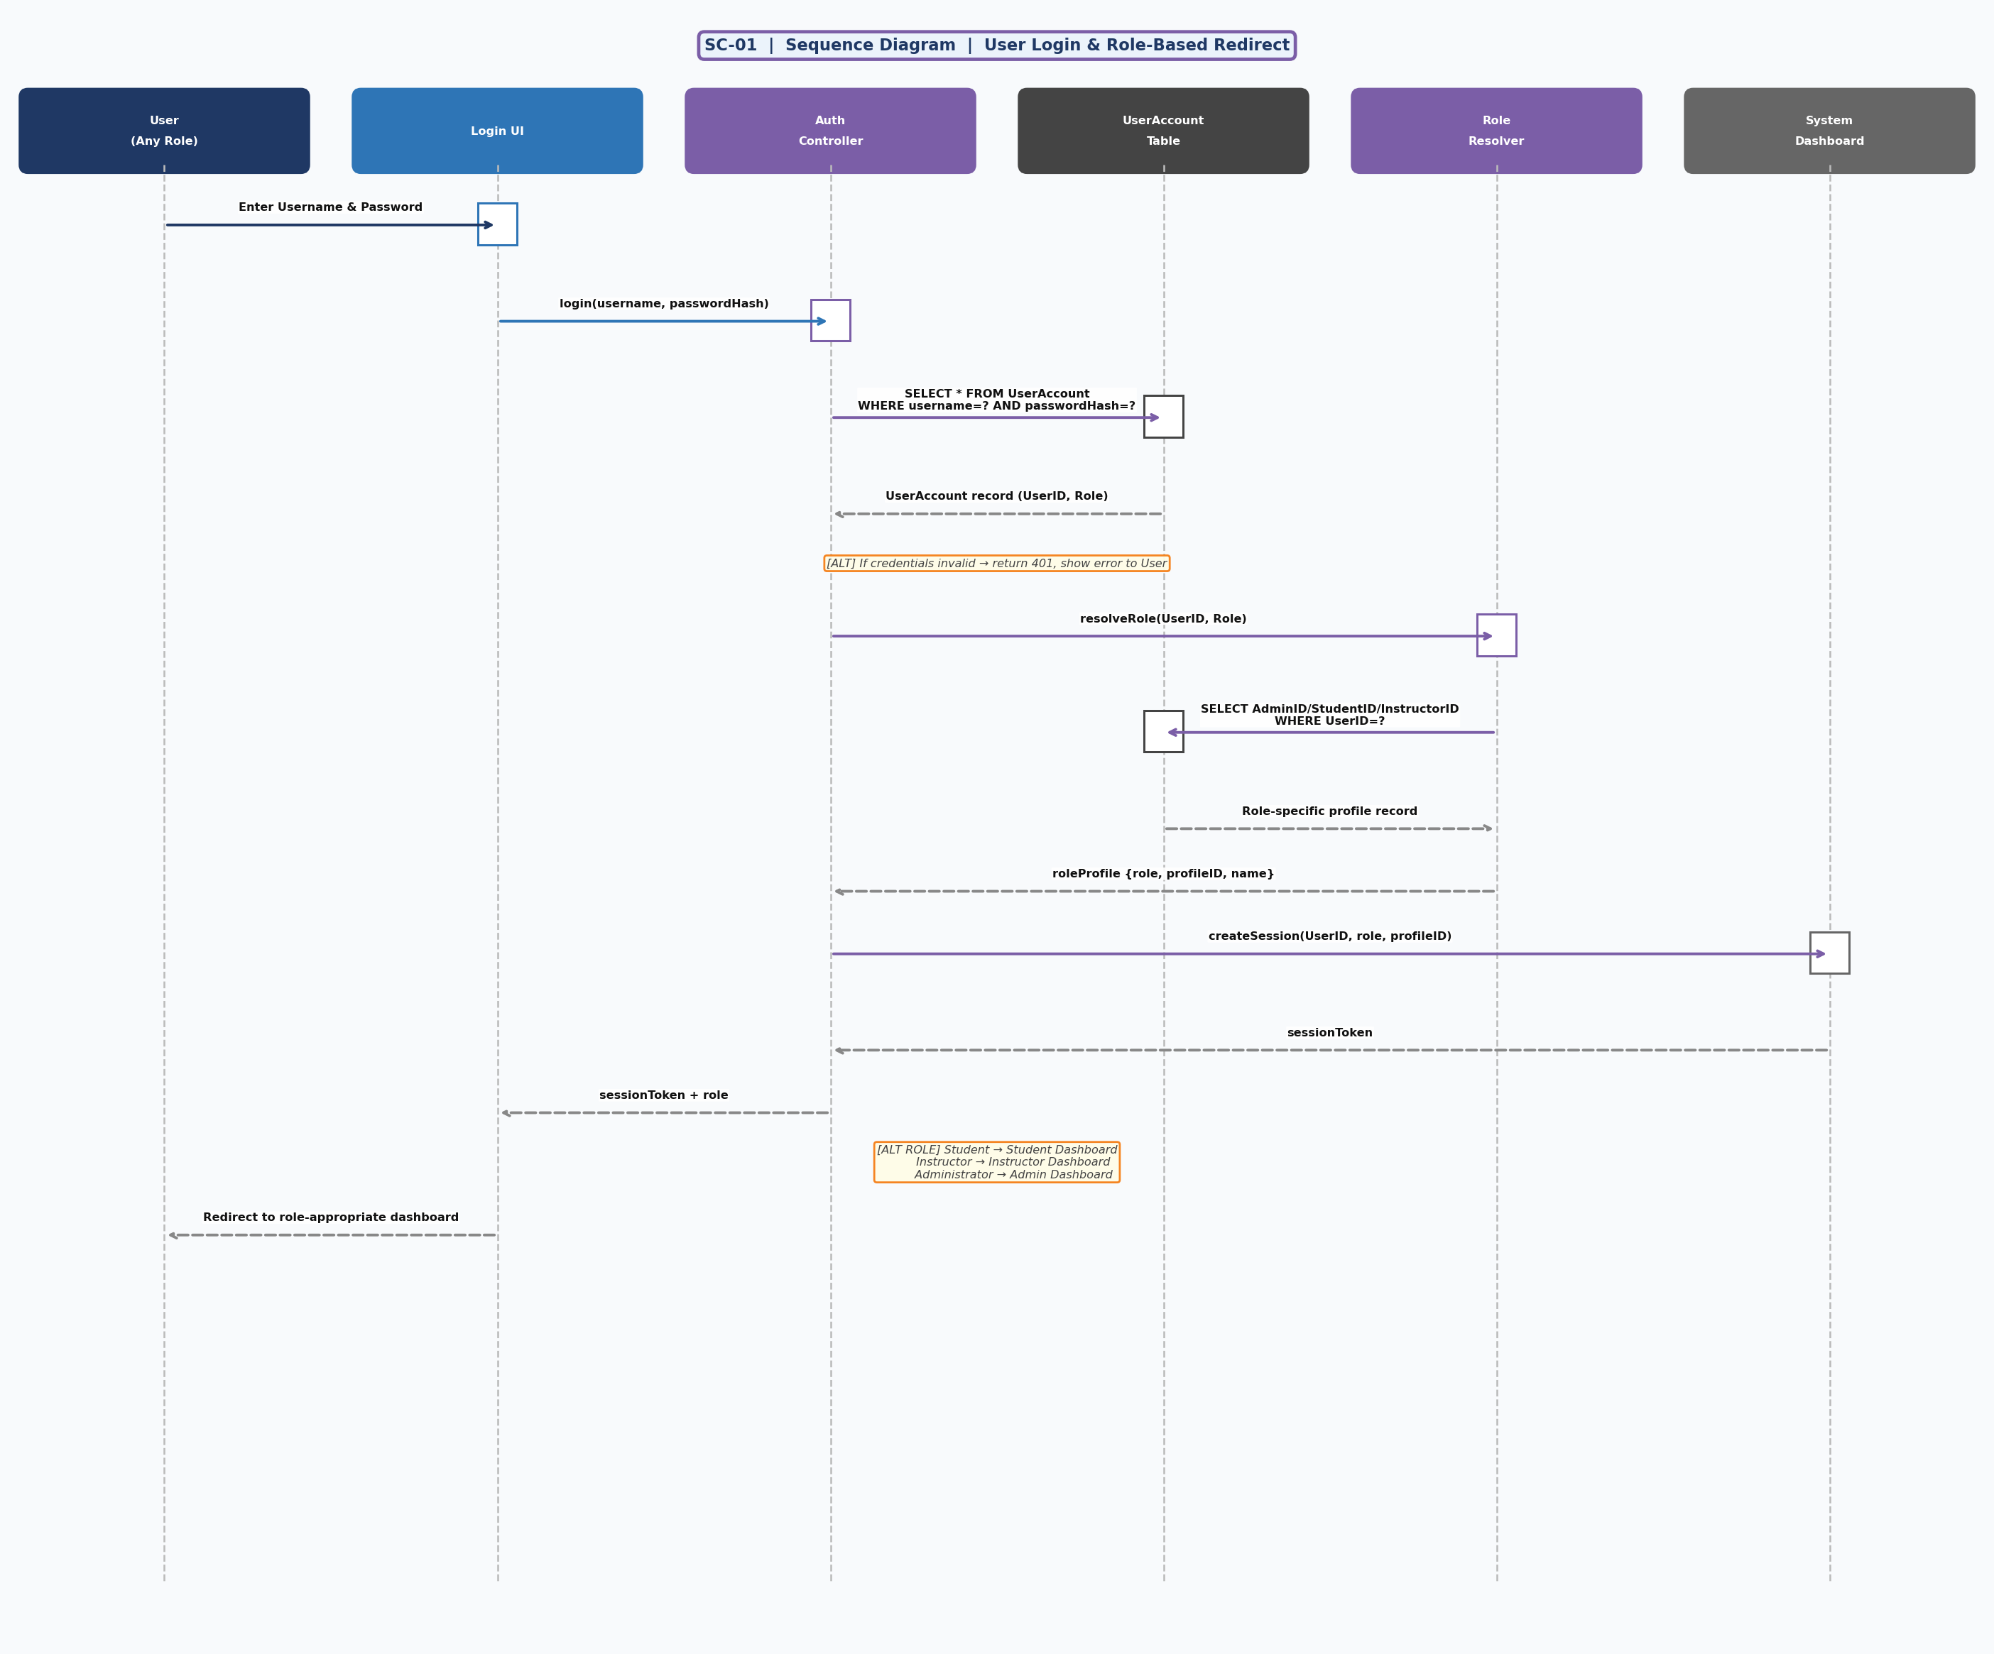
SC-01 — User Login & Role-Based Redirect

SC-02 — Student Registers in a Course

Use Case: UC-01 (Register for Course)

Student browses courses (filtered by Semester), selects a CourseID, and the system creates an Enrollment record (StudentID FK, CourseID FK, EnrollmentDate, Status="Active"). A Notification is inserted (StudentID FK, NotificationText, NotificationDate). The ALT fragment prevents duplicate enrollment.

ERD Entities & Attributes referenced:
• Enrollment: EnrollmentID, StudentID (FK), CourseID (FK), EnrollmentDate, Status
• Course: CourseID, CourseName, Credits, Semester, InstructorID (FK)
• Notification: StudentID (FK), NotificationText, NotificationDate
• Relationship: Student –RegistersIn→ Enrollment –Includes→ Course
Actors: Student

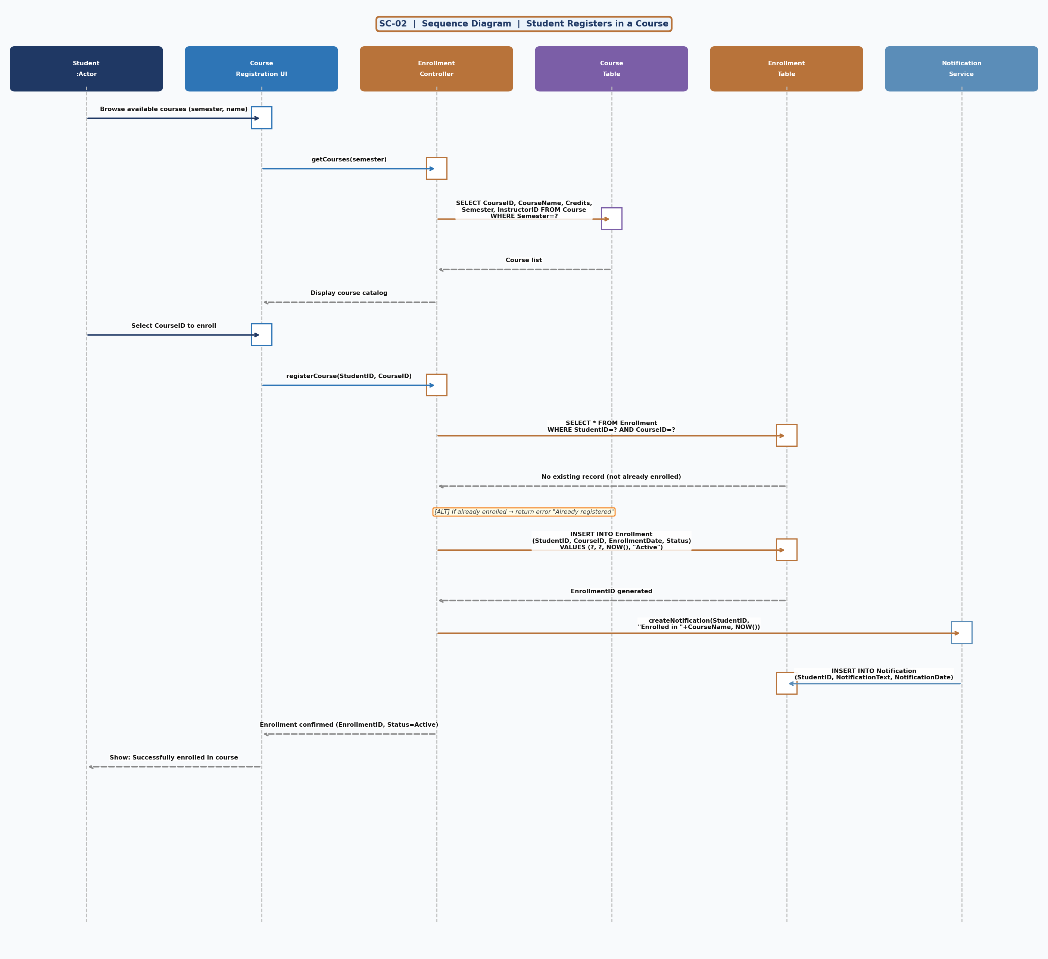
SC-02 — Student Registers in a Course

SC-03 — Instructor Posts Grade → Notification Triggered

Use Case: UC-02 (Post Final Grades)

Instructor selects a course, fetches active Enrollment roster (StudentID, EnrollmentID), enters GradeValue and Remarks, which are saved to the Grade table (EnrollmentID FK, GradeValue, GradeDate, Remarks). The ERD "Triggers" relationship between Grade and Notification is realised: a Notification row is inserted (StudentID FK, GradeID FK, NotificationText, NotificationDate) and the student is emailed.

ERD Entities & Attributes referenced:
• Grade: GradeID, EnrollmentID (FK), GradeValue, GradeDate, Remarks
• Notification: NotificationID, StudentID (FK), GradeID (FK), NotificationText, NotificationDate
• Relationship: Enrollment –Receives→ Grade; Grade –Triggers→ Notification; Student –Receives→ Notification
Actors: Instructor

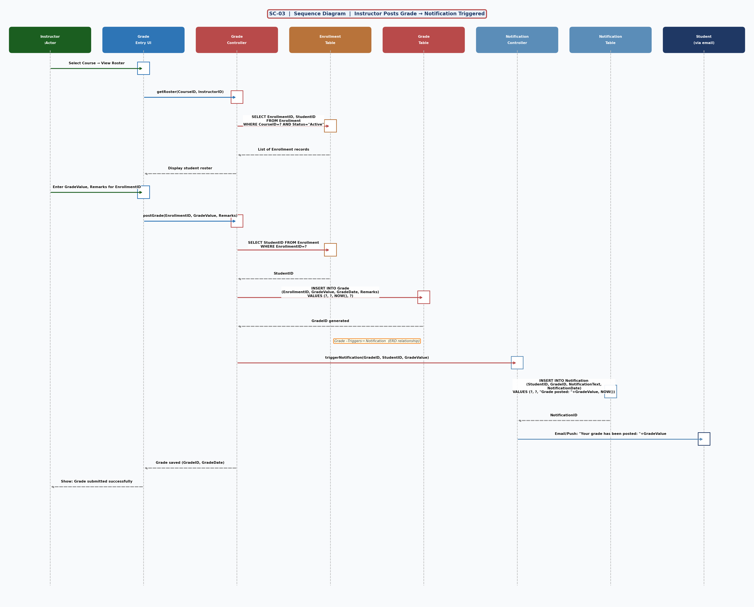
SC-03 — Instructor Posts Grade → Notification Triggered

SC-04 — Student Views Their Grades

Use Case: UC-03 (View Grades)

Retrieves all Enrollment records for the Student, joins to Grade (via EnrollmentID FK) and Course (via CourseID FK) to produce a full grade report with CourseName, Semester, Credits, GradeValue, GradeDate and Remarks. The ALT fragment handles the case where no grades have been posted yet.

ERD Entities & Attributes referenced:
• Enrollment: EnrollmentID, StudentID (FK), CourseID (FK), Status
• Grade: GradeID, EnrollmentID (FK), GradeValue, GradeDate, Remarks
• Course: CourseID, CourseName, Credits, Semester
• Relationship: Student –RegistersIn→ Enrollment –Receives→ Grade
Actors: Student

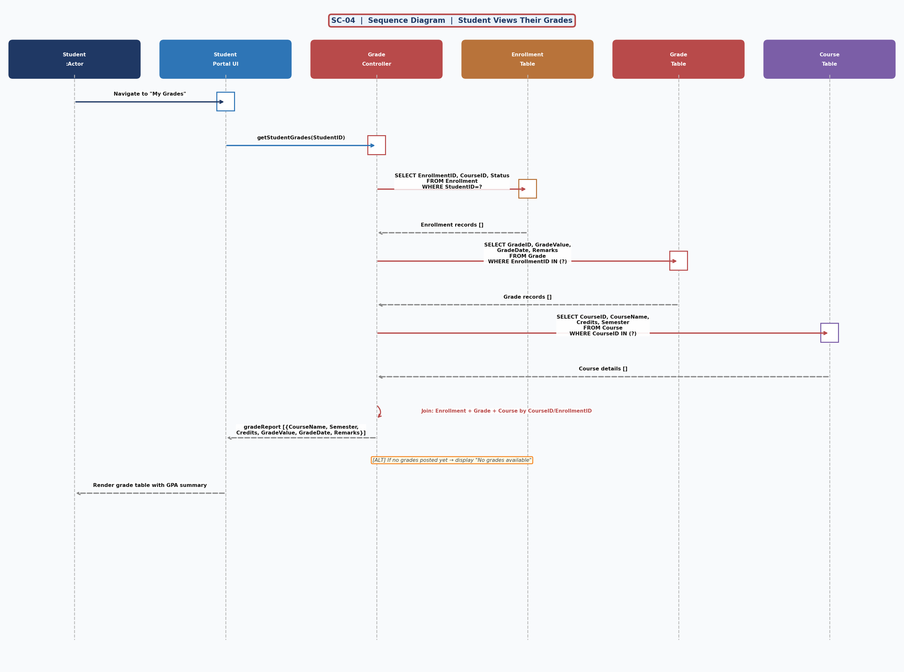
SC-04 — Student Views Their Grades

SC-05 — Student Sends Message to Instructor

Use Case: UC-05 (Send Message)

Student selects an Instructor from a course-filtered list, types MessageText, and the system inserts a Message record (StudentID FK, InstructorID FK, MessageText, SentDate). The ERD "Sends" relationship from Student to Message and "Receives" relationship from Instructor to Message are fully traced.

ERD Entities & Attributes referenced:
• Message: MessageID, StudentID (FK), InstructorID (FK), MessageText, SentDate
• Relationship: Student –Sends→ Message; Instructor –Receives→ Message
Actors: Student

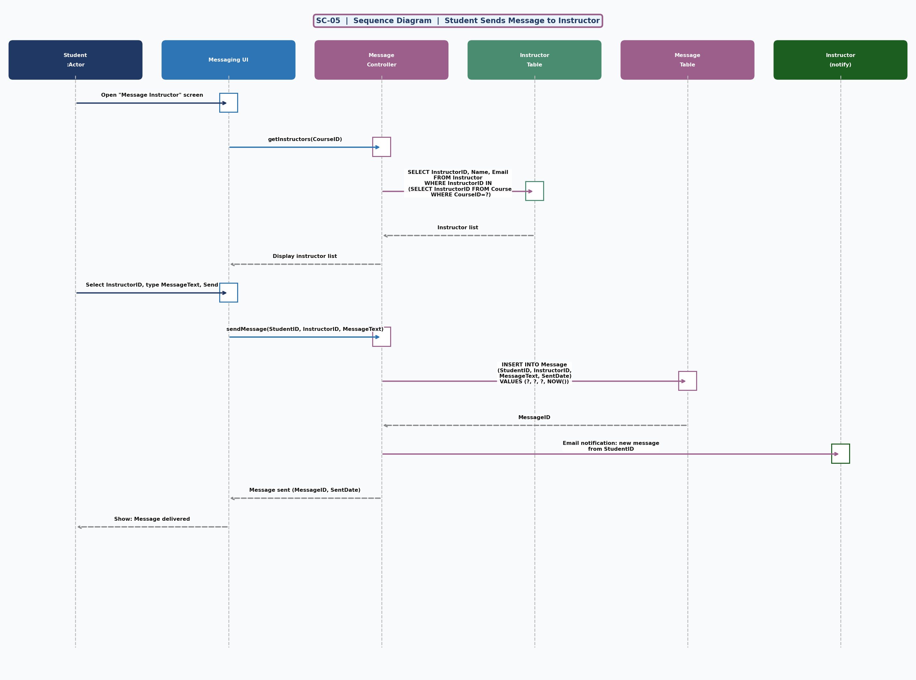
SC-05 — Student Sends Message to Instructor

SC-06 — Instructor Uploads Course Material

Use Case: UC-06 (Upload Course Material)

Instructor uploads a file for a course they own (InstructorID FK on Course verified). File is stored and a CourseMaterial record is created (CourseID FK, Title, FileURL, UploadDate). The ERD "Has" relationship between Course and CourseMaterial is directly exercised. ALT handles unauthorised access (InstructorID mismatch).

ERD Entities & Attributes referenced:
• CourseMaterial: MaterialID, CourseID (FK), Title, FileURL, UploadDate
• Course: CourseID, CourseName, InstructorID (FK)
• Relationship: Course –Has→ CourseMaterial; Instructor –Teaches→ Course
Actors: Instructor

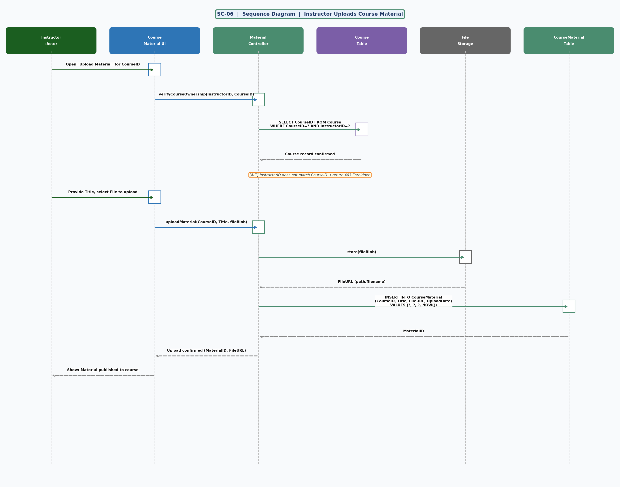
SC-06 — Instructor Uploads Course Material

SC-07 — Student Views Course Materials

Use Case: UC-07 (View Course Materials)

Access is gated on an active Enrollment record (StudentID FK, CourseID FK, Status="Active"). Once verified, all CourseMaterial rows for the CourseID are returned (MaterialID, Title, FileURL, UploadDate) ordered by upload date. Student downloads via FileURL. ALT handles unenrolled access attempts.

ERD Entities & Attributes referenced:
• Enrollment: EnrollmentID, StudentID (FK), CourseID (FK), Status
• CourseMaterial: MaterialID, CourseID (FK), Title, FileURL, UploadDate
• Relationship: Course –Has→ CourseMaterial (student accesses via Enrollment)
Actors: Student

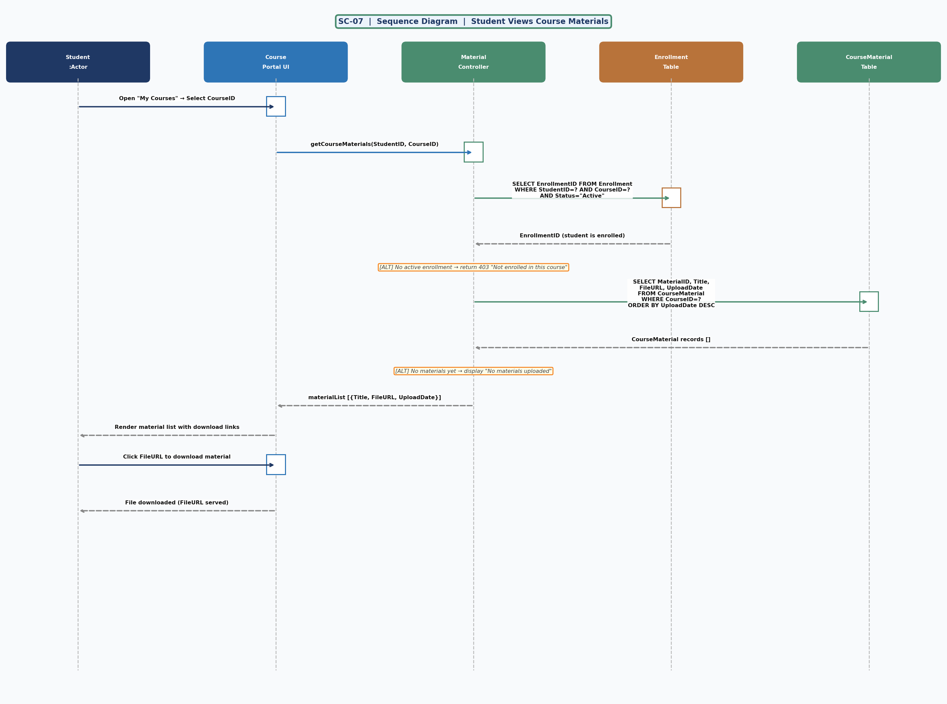
SC-07 — Student Views Course Materials

SC-08 — Student Views Notifications

Use Case: UC-08 (View Notifications)

Retrieves all Notification records for the StudentID (NotificationID, GradeID FK, NotificationText, NotificationDate) ordered newest first. Then enriches with Grade detail (GradeValue, Remarks) via GradeID FK join. Implements the ERD "Student –Receives→ Notification" and "Grade –Triggers→ Notification" relationships.

ERD Entities & Attributes referenced:
• Notification: NotificationID, StudentID (FK), GradeID (FK), NotificationText, NotificationDate
• Grade: GradeID, EnrollmentID (FK), GradeValue, GradeDate, Remarks
• Relationship: Student –Receives→ Notification; GradeID FK links back to the triggering Grade
Actors: Student

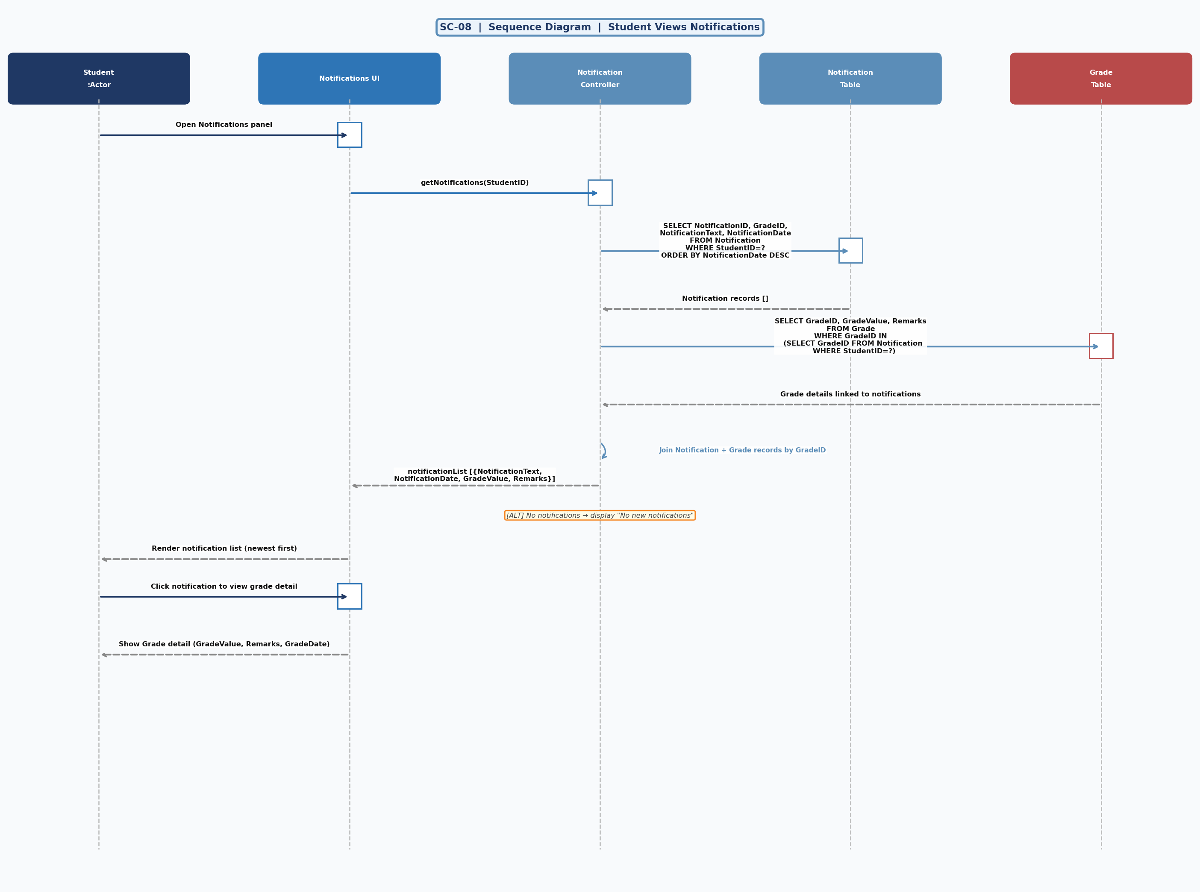
SC-08 — Student Views Notifications

SC-09 — Administrator Manages User Accounts

Use Case: UC-09 (Manage User Accounts)

Admin creates users by inserting into UserAccount (Username, Email, PasswordHash, Role) then inserting a corresponding role-profile record (Student, Instructor, or Administrator table). Deactivation sets Role="Inactive" in UserAccount. Exercises the ERD HasRole relationship from UserAccount to all three role tables.

ERD Entities & Attributes referenced:
• UserAccount: UserID, Username, Email, PasswordHash, Role
• Administrator: AdminID, UserID (FK), Name, Role
• HasRole relationship: UserAccount → Administrator / Student / Instructor
Actors: Administrator

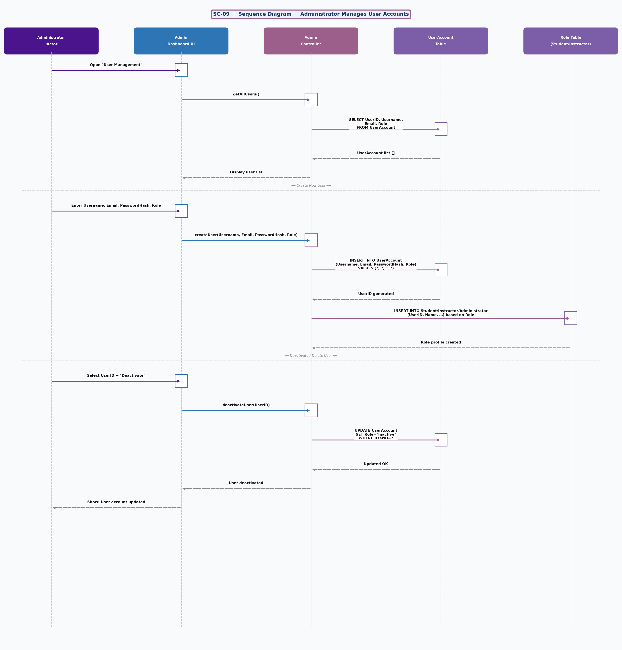
SC-09 — Administrator Manages User Accounts

SC-10 — Instructor Replies to Student Message

Use Case: UC-10 (Reply to Message)

Instructor views inbox (Message rows WHERE InstructorID=?), selects a thread, and sends a reply by inserting a new Message row (StudentID FK, InstructorID FK, replyText, NOW()). Student is notified by email. Exercises both "Instructor –Receives→ Message" and "Student –Sends→ Message" relationships in reverse.

ERD Entities & Attributes referenced:
• Message: MessageID, StudentID (FK), InstructorID (FK), MessageText, SentDate
• Relationship: Instructor –Receives→ Message; reply is a new Message row same FK pair
Actors: Instructor

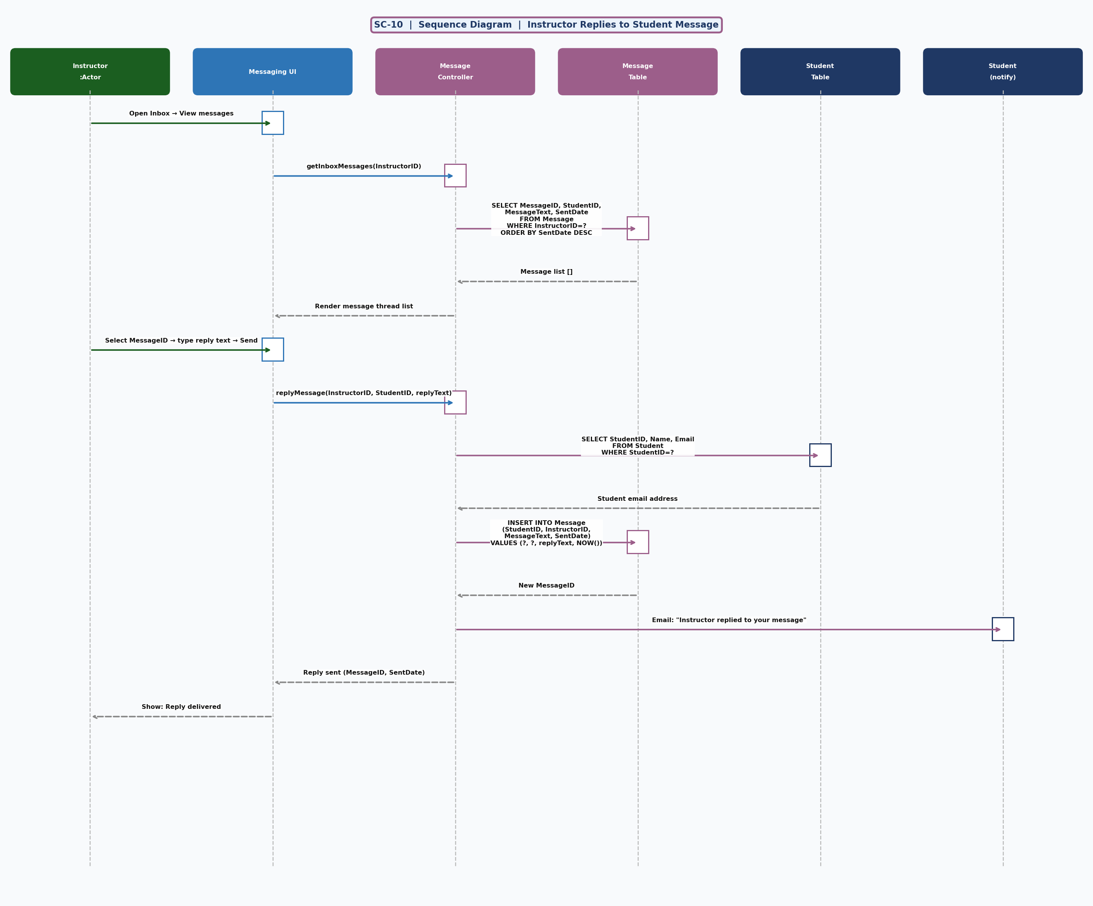
SC-10 — Instructor Replies to Student Message

SC-11 — Student Drops a Course

Use Case: UC-11 (Drop / Withdraw from Course)

Student selects an active enrollment and requests a drop. System updates Enrollment.Status from "Active" to "Dropped". A Notification is created to confirm the drop. The ALT fragment prevents double-drop. Status field on Enrollment is the key ERD attribute exercised.

ERD Entities & Attributes referenced:
• Enrollment: EnrollmentID, StudentID (FK), CourseID (FK), EnrollmentDate, Status
• Status transitions: Active → Dropped
• Notification: StudentID (FK), NotificationText, NotificationDate
Actors: Student

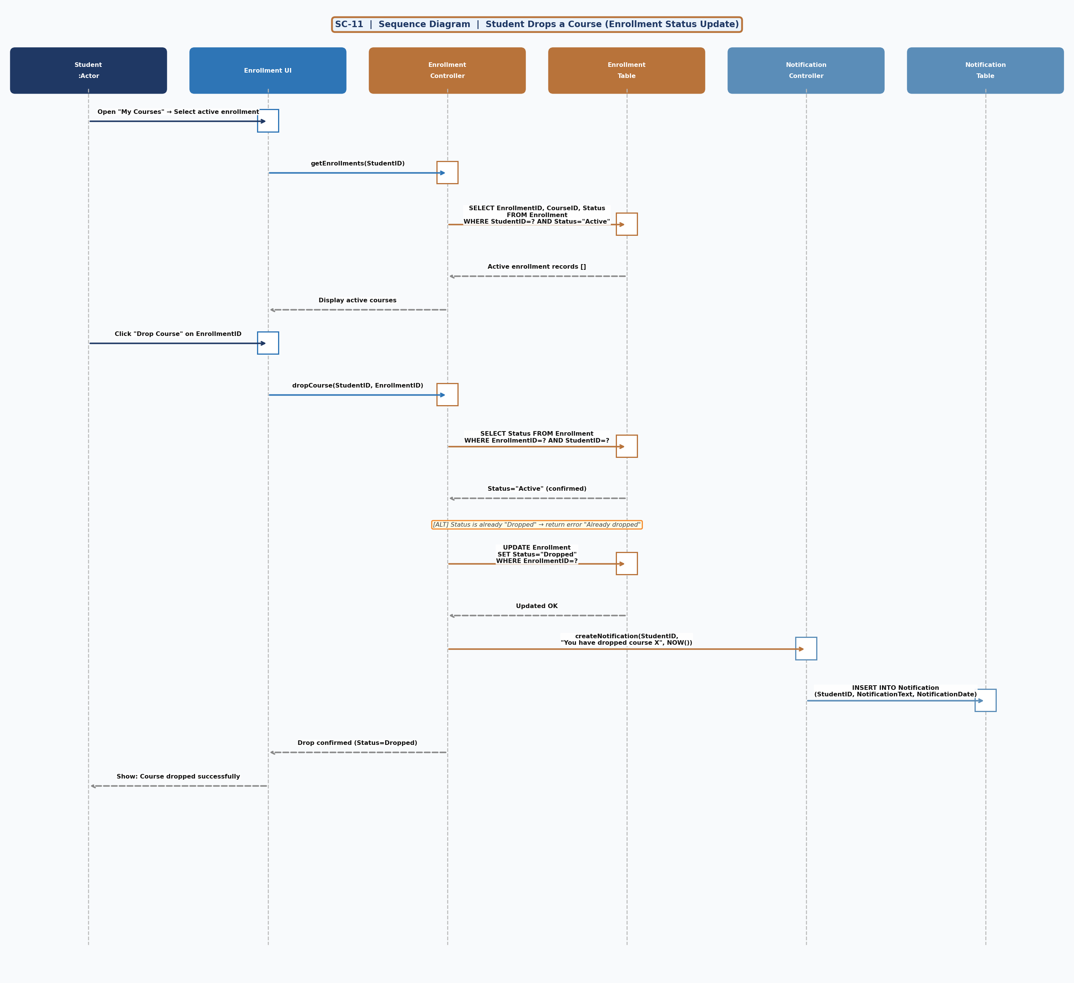
SC-11 — Student Drops a Course

SC-12 — Instructor Views Course Roster & Student Profiles

Use Case: UC-12 (View Course Roster)

Instructor sees their courses (InstructorID FK on Course). Selecting a course shows the active Enrollment roster, enriched with Student profile data (Name, Email, AcademicHistory) and any posted Grade records. Exercises Instructor –Teaches→ Course, Course –Includes→ Enrollment, Student –RegistersIn→ Enrollment, Enrollment –Receives→ Grade.

ERD Entities & Attributes referenced:
• Course: CourseID, CourseName, Semester, Credits, InstructorID (FK)
• Enrollment: EnrollmentID, StudentID (FK), CourseID (FK), Status
• Student: StudentID, Name, Email, AcademicHistory
• Grade: GradeID, EnrollmentID (FK), GradeValue
• Relationships: Instructor –Teaches→ Course –Includes→ Enrollment –Receives→ Grade
Actors: Instructor

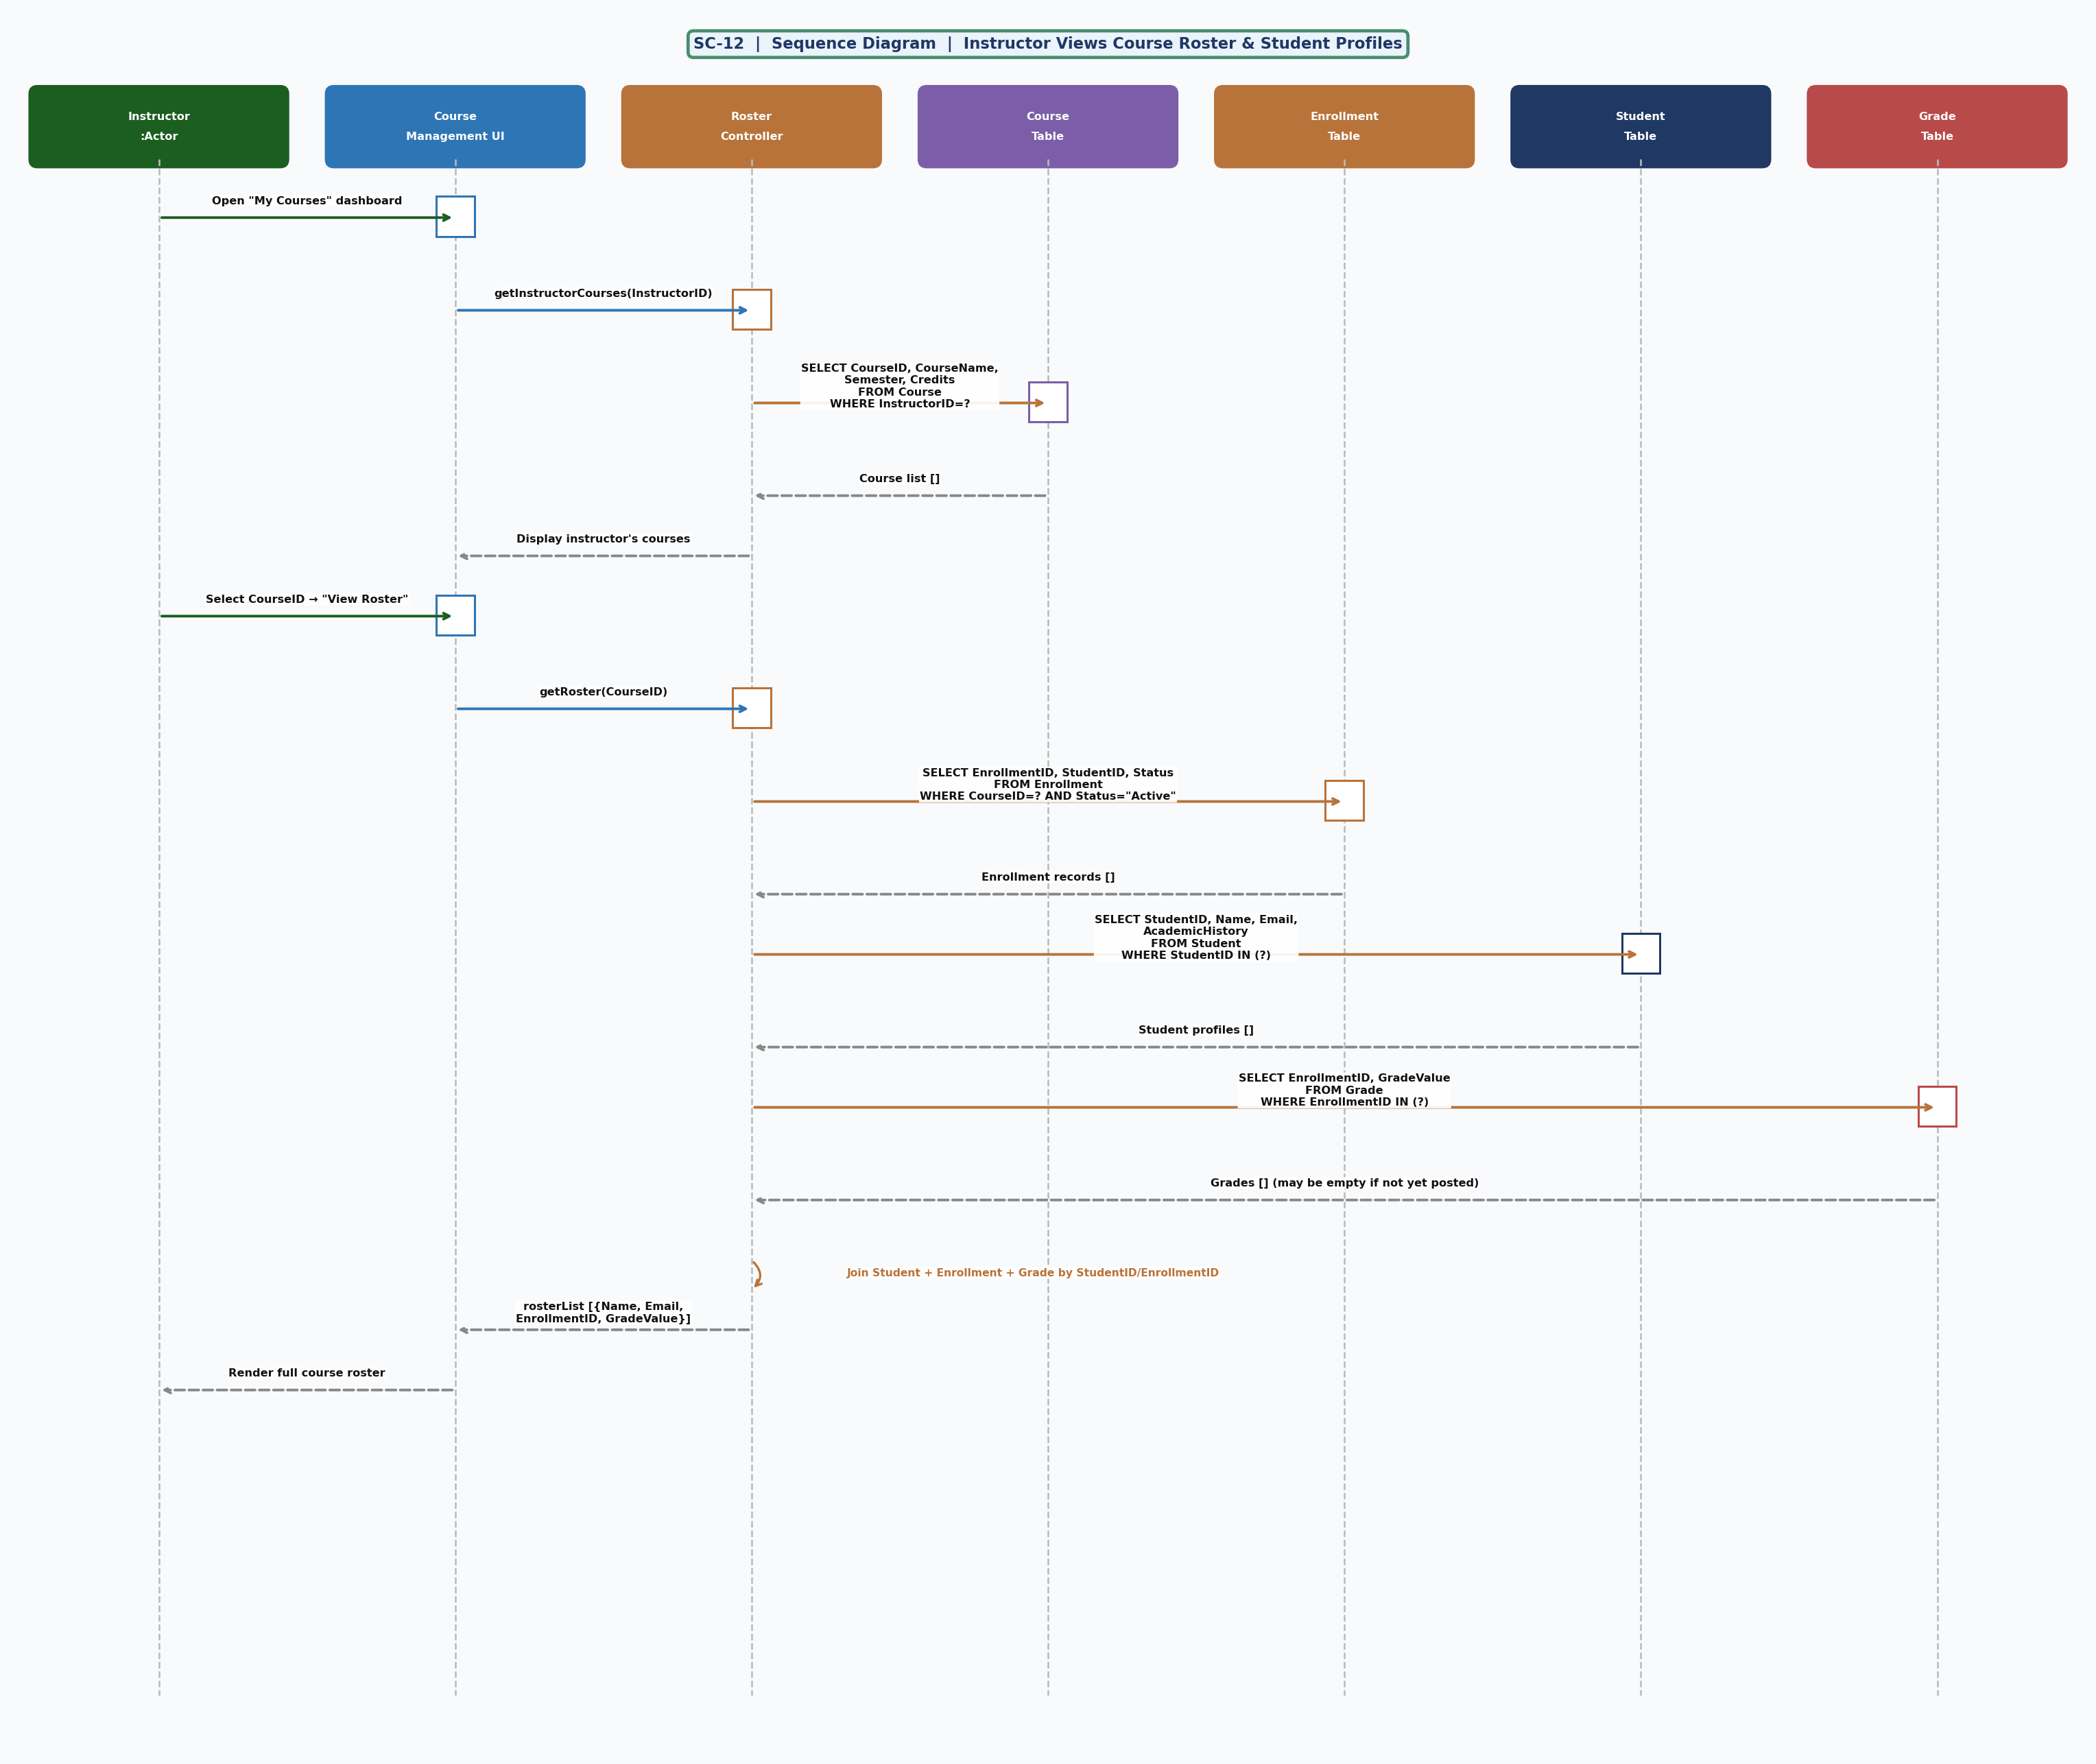
SC-12 — Instructor Views Course Roster & Student Profiles

Traceability: ERD Entities → Sequence Diagrams
The table below confirms every ERD entity is covered by at least one sequence diagram.

UserAccount (UserID, Username, Email, PasswordHash, Role) → SC-01, SC-09
Administrator (AdminID, UserID FK, Name, Role) → SC-09
Student (StudentID, UserID FK, Name, DOB, Address, Phone, Email, AcademicHistory) → SC-02, SC-03, SC-04, SC-05, SC-07, SC-08, SC-11, SC-12
Instructor (InstructorID, UserID FK, Name, Email, Department) → SC-03, SC-05, SC-06, SC-10, SC-12
Course (CourseID, CourseName, Credits, Semester, Description, InstructorID FK) → SC-02, SC-06, SC-07, SC-12
Enrollment (EnrollmentID, StudentID FK, CourseID FK, EnrollmentDate, Status) → SC-02, SC-03, SC-04, SC-07, SC-11, SC-12
Grade (GradeID, EnrollmentID FK, GradeValue, GradeDate, Remarks) → SC-03, SC-04, SC-08, SC-12
CourseMaterial (MaterialID, CourseID FK, Title, FileURL, UploadDate) → SC-06, SC-07
Notification (NotificationID, StudentID FK, GradeID FK, NotificationText, NotificationDate) → SC-02, SC-03, SC-08, SC-11
Message (MessageID, StudentID FK, InstructorID FK, MessageText, SentDate) → SC-05, SC-10

ERD Relationships traced:
• HasRole (UserAccount → Administrator / Student / Instructor) → covered in: SC-01, SC-09
• RegistersIn (Student → Enrollment) → covered in: SC-02, SC-11
• Includes (Enrollment → Course) → covered in: SC-02, SC-12
• Receives/Grade (Enrollment → Grade) → covered in: SC-03, SC-04, SC-12
• Triggers (Grade → Notification) → covered in: SC-03, SC-08
• Receives/Notif (Student → Notification) → covered in: SC-08, SC-11
• Teaches (Instructor → Course) → covered in: SC-06, SC-12
• Has (Course → CourseMaterial) → covered in: SC-06, SC-07
• Sends (Student → Message) → covered in: SC-05
• Receives/Msg (Instructor → Message) → covered in: SC-10

